**Title**: Cognitive and Learning Tasks to Assess the Effect of Mood on Motivation

# Principle Investigator:

1. Dylan Nielson, PhD

Staff Scientist

Machine Learning Team, NIMH-IRP

Other NIH Research Team:

1. Song Qi, PhD

Non-NIH Collaborators:

1. Per Sederberg, PhD (University of Virginia)
2. David Jangraw, PhD (University of Vermont)

# Background/Introduction

Reward processing refers to how organisms represent, experience, and behave towards rewards (e.g., the search for food when hungry). It includes the anticipation of a reward following a cue, and the experience of receiving (or being deprived of) a reward. Indeed, it is thought that the difference between an organism’s reward expectation and the actual reward outcome generates a dopamine-encoded signal: the prediction error (PE). The PE drives reward learning and subsequent behavior: a surprisingly rewarded behavior will lead to a positive PE and is more likely to be repeated; a fully predicted reward does not engender such an effect. Reward processing aberrations are strongly related to motivation and implicated in the disorders, such as depression and anxiety.

The last ten years have seen substantial progress in examining reward processing in humans, including the anticipation of a reward as well as its learning through the PEs it generates. A number of behavioral tasks have been developed and used in healthy populations and in patients. However, one important drawback of such research is sample size. Bringing participants into the laboratory in order to complete a task can be both costly and inconvenient for the subject. Online behavioral testing is now becoming increasingly common and is not being used by major laboratories around the world (Brown et al., 2014) that are interested in reward processing. The advantage of such online testing is that it can be scaled to larger samples. Also, it is convenient for the subject, as they can complete the task within their chosen time (e.g., after coming back from work). Our proposal here involves the use of modern technology to capture reward

processing aberrations through behavioral tasks delivered online. Crucially, this data collection does not involve the collection of personally identifying information (PII).

Our group has previously shown that the way our brain processes rewards (such as an amount of money, or a favorite present) may be related to our risk for depression and other conditions (Stringaris, Vidal-Ribas et al 2015 AJP, Pornpattananangul 2019 JAMA Psych). Despite these findings, our understanding of the behavioral responses that underlie reward processing—such as the way we choose and the rate at which we learn from rewards—is still only partly understood.

In addition, *environmental factors* strongly influence reward processing through the decision- making process. In daily life, under different circumstances, people often react differently to the same stimulus. For example, under a hypothetical scene of robbery, when equipped with defensive tools, people tend to display more approach, rather than avoidance behaviors, and experience less fear, compared to when they are bare-handed. Emotional responses play a vital role in human decision-making.

Humans, like other animals, have evolved a set of neural circuits whose primary function is to coordinate the information received from the immediate surroundings and the value-based decision-making process to optimize reward gain and survival (Qi et al., 2018). However, the direct relationship between environmental contingency (often also termed *context*, or *affordance*) and reward processing is only partially explored and there is no literature examining the direct interaction between environmental contingency and the decision-making process. This work will explore this further by linking environmental contingency to behaviors and emotional responses under a decision-making scenario that involves a potential gain of reward.

Environmental contingency describes the resources and action capacity an organism possesses within a specific environment or situation. Environmental affordances cannot be described within the value-neutral language of physics, but rather, introduces “notions of benefits and injuries to someone” (Gibson, 2014). It has since been studied as important in emotional regulation (Sheppes et al., 2014; Suri et al., 2018).

Another important problem we wish to address is disentangling the relationship between decision- making choices, mood ratings and symptoms of depression and related disorders. This question is fundamental to all experiments that many groups concerned with mood research are examining throughout the world.

Mood does not only respond to explicit rewards, but we have also seen that it responds to the receipt of implicit rewards such as novelty and implicit costs such as opportunity costs. We would like to include additional tasks and questionnaires to determine how these implicit rewards and costs influence mood and if there may be other factors influence mood such as mind wandering and boredom. This will help us contextualize our findings on the relationship between mood, reward, and decision making.

# Study Objectives

The aim of our work is to use behavioral tasks that will help us to better understand reward processing in humans.

The primary objective of this study is to increase our understanding of behaviors associated with reward processing. Specifically, we will investigate the effect of learning and mood and environmental contingency on decision-making. We will explore how rewards influence mood and decisions that are made. We wish to apply these tasks as pilots with ordinary, non-selected adults. Our objective is further advanced by the addition of the Contingency Task (ConTA).

ConTA measures people’s behavior and emotional responses to the same stimulus, yet under different environmental contingencies. ConTA is a new online behavioral task that links environmental contingency to behaviors and emotional responses under a decision-making scenario that involves a potential gain of reward. Decision-making under threat, in particular, is of great important to the wellbeing and survival of an individual. By studying this dynamic, we will gain insights into the relationship between daily life environments, emotional wellbeing, and reward processing.

A further objective is trying to learn the relationship between decision-making choices, mood ratings, and symptoms of depression and related disorders. In the tasks that our group and others are using to assess mood, a subject is asked to rate their mood around the time when they make a selection in a decision-making game (e.g., to pursue an option or not). They rate their mood on a scale from 1 (lowest) to 10 (highest) or similar (Keren et al 2021). One of the key questions is whether participants are rating their mood according to how they feel or whether their goal is purely to maximize gains, rather than record their feelings.

To answer this question, we also have developed a novel and simple task, the Mood-o-Meter, which may untangle selection choice from mood rating and provide the opportunity to examine the relationship between mood and reward independently. This will be crucial in allowing us to validate the ratings of mood.

# Study population

The study population is adults in the US or UK who are 18 year of age or older. In some cases the third-party platforms may screen participants for inclusion based on some or all of the following factors:

1. History of acceptable task performance on previous online tasks as indicated by the platforms through which we recruit participants.
2. Access to the computers capable of running downloaded cognitive tasks.
3. Responses to screening questions regarding the presence or absence of mental health disorders.

We plan to present these to a total number of subjects that will not exceed 10,000. Depending on the results of these 10,000 individuals, we may request in future for more individuals to participate in our study, i.e., increase the enrollment ceiling.

# Recruitment and Screening:

Participants will be recruited and compensated via one of the participant management platforms (PMPs) described below. Here, the term “participant management platform” is used to describe a participant management service that is available on the Internet through which participants find our experiments and which manage participant compensation. PMPs include Mechanical Turk (MTurk), Prolific, YouGov, and Cloud Research. . The Investigators will deliver tasks and questionnaires to participants via one of two “data collection platforms,” (DCPs) SurveyMonkey or Pavlovia, which are completely separate from the PMPs. PMPs will be used to make tasks or questionnaires available to participants, potentially on the basis of screening questions described in detail below. PMPs will not be used to collect task or questionnaire data and have no access to the responses collected by the DCPs. Reciprocally, DCPs have no access to any information collected about participants by PMPs.

YouGov is an exception to the separation between DCPs and PMPs described above. They do not allow the participants they manage to complete surveys on any other platform, so they will act as both a PMP and DCP. Personally identifiable information (PII) collected by the participant management portion of YouGov is not stored with the data collection portion of YouGov. Members of the team managing data collection on YouGov do not have access to that PII, and access to the information is very restricted.

***Amazon Mechanical Turk***

Amazon Mechanical Turk enables individuals and businesses to coordinate the use of people to perform tasks online. It is owned by Amazon. Employers and researchers can post various types of jobs, such as choosing the best among several photographs of a storefront, writing product descriptions, or identifying performers on music CDs, or participating in tests. Individuals participating in these jobs are called “Mechanical Turk Worker”. They can browse among existing jobs and complete them in exchange for a monetary payment set by the requester (i.e., here the Principal Investigator). Mechanical Turk allows requestors to select criteria that workers must meet. To ensure collection of quality data, we are setting a requirement that workers have completed at least 5,000 jobs with a 95% satisfactory completion rate. Jobs are only made available to workers that meet these criteria. Mechanical Turk Workers provide Amazon with personal identifiers as part of this process, specifically names and addresses, so that they can be compensated for the jobs they complete, but Amazon will not provide us with this information. The Mechanical Turk Worker ID will be used by Amazon MTurk to distribute payment to the Workers but will not be stored with the survey responses or data.

Mechanical Turk does not collect any sensitive health information (e.g. Protected Health Information, or PHI) about participants. When selecting participants on Mechanical Turk, we only screen based on previous performance of Mechanical Turk jobs (number of jobs completed, % successful completions), location (within USA), or if they have completed any similar tasks for us in the past. None of the screening criteria are based on questions collected from participants. Furthermore, as noted above, Mechanical Turk is only a means of sending a link to the DCP. None of the responses to questionnaires on the DCP are visible to Mechanical Turk or capable of being linked to participants by Mechanical Turk.

***Cloud Research***

Cloud Research is a platform based on Mechanical Turk that provides additional functionality for researchers. “Cloud Research ascertains, maintains and, to ensure data quality, curates a panel of research participants who have answered a large battery of screening questions. The screening questions and procedures are created by Cloud Research; none of the screening questions or procedures were designed by NIH Investigators or for this study. NIH Investigators rely on the platform's screening questions to determine who is eligible for this study. Researchers can work with Cloud Research to get access to specific portions of their participant panel based on data quality requirements and responses to the battery of the platform’s screening questions. Participants that meet the researchers desired screening requirements are given the opportunity to complete that researchers’ jobs. When working with Cloud Research, for purposes of payment, the Investigators on this protocol may receive participants Cloud Research IDs, but the Investigators on this protocol do not receive any information that would link the identifier to any individual or store the unique identifier with survey responses or data. Cloud Research obtains personal identifiers but does not provide us with that information. Cloud Research has a way to link identifiers to the screening data, but not the task or questionnaire data. *No* identifiers are embedded in the data NIH will receive.

Depending on the task, we may select participants who have indicated they do or do not believe they have Depression, Anxiety, or ADHD. The Cloud Research screening question relevant to our research is:

“Have you ever been diagnosed with or have reason to believe you have any of the following conditions? Please select all that apply:

ADHD

Hypertension

Heart Disease

High Cholesterol

Diabetes

Asthma

Depression

Anxiety

Eating Disorder

Reflux (GERD)

Irritable Bowel Syndrome (IBS)

Ulcers

Rheumatoid Arthritis (RA)

Insomnia

Cancer

Seasonal Allergies

Food Allergies

Psoriasis

Neurological Illness or Injury

Permanent Physical Disability

None of the Above”

***Prolific***

Prolific is similar to Mechanical Turk except that it is focused primarily on facilitating research instead of the broader scope of jobs that participants may be asked to complete on Mechanical Turk. Prolific does not use the Mechanical Turk platform. Prolific ascertains, maintains and to ensure data quality, curates a panel of research participants who have answered a large battery of screening questions . The screening questions and procedures are created by Prolific; none of the screening questions or procedures were designed by NIH Investigators or for this study. NIH Investigators rely on the platform's screening questions to determine who is eligible for this study. Researchers can select screening questionnaire responses for inclusion and exclusion and participants that meet those requirements are given the opportunity to complete that researchers’ jobs. Prolific manages participant reimbursement and, to fulfill this, collects identifiable information from participants. However, Prolific does not provide any identifiable information to researchers. Participant responses are linked with a unique identifier, but the Investigators on this protocol do not receive any information that would link the identifier to any individual or store the unique identifier with survey responses or data. Prolific has a way to link identifiers to the screening data, but not the task or questionnaire data. *No* identifiers are embedded in the data NIH will receive.

Prolific collects and maintains a bank of questions/responses from each participant. When we use Prolific, we may filter participants based on their responses to specific questions that are already in the Prolific bank of questions. Five of these questions are yes or no questions:

* Do you experience depression?
* Do you experience anxiety?
* Do you consider yourself to have attention deficit disorder (ADD)/attention deficit hyperactivity disorder (ADHD)?
* Do you have any diagnosed mental health condition that is uncontrolled (by medication or intervention) and which has a significant impact on your daily life / activities?
* Do you have – or have you had – a diagnosed, on-going mental health/illness/condition?

This question allows multiple responses:

* Which operating system does your primary personal computer run? (please select all that apply)
* Chrome OS
* macOS
* Ubuntu
* Windows 10 Home Edition
* Windows 10 Pro Edition
* Windows 10 (Other Editions)
* Windows 10 (Unsure of the edition)
* Windows (Other versions)
* Other
* I don’t have a personal computer
* Don’t know / rather not say
* Windows 11

***YouGov***

YouGov is primarily an opinion polling company. Like Prolific and Cloud Research, YouGov ascertains, maintains and, to ensure data quality, curates a panel of research participants who have answered a large battery of screening questions. The screening questions and procedures are created by YouGov; none of the screening questions or procedures were designed by NIH Investigators or for this study. YouGov will work with the NIH Investigators to select appropriate questions for identifying individuals with or without depression, anxiety, or ADHD, but has not provided the relevant questions. NIH Investigators rely on the platform's screening questions to determine who is eligible for this study. Researchers can select screening questionnaire responses for inclusion and exclusion and participants that meet those requirements are given the opportunity to complete that researchers’ jobs. Unlike other platforms, YouGov reimburses participants with Amazon Gift Cards. YouGov collects identifiable information from participants but does not provide that information to researchers. Participant responses are linked to a unique identifier, but the Investigators on this protocol do not receive any information that would link the identifier to any individual or store the unique identifier with survey responses or data. YouGov has a way to link identifiers to the screening data but *no* identifiers are embedded in the data NIH will receive.

# Consent Process:

There is no consent form. Previously we used a single information sheet (version 4); beginning with Amendment F, we will use one specific information sheet to provide information to one specific task or session being collected. The information sheet template and specific information sheets for each experiment are included. Participants will be consented via information displayed on the platform (see enclosed consent information). The participant will signal their consent by proceeding to click "I agree" after reading the consent information. We include the following information as part of the introduction to the tasks on every PMP: 1) the activity is being conducted for research purposes; 2) that participation is voluntary; 3) a description of the procedures involved (e.g. approximate time commitment, types of questions and tasks, etc.); 4) general purpose of the research; 5) any anticipated risks; 6) methods for withdrawal from the study and whether subject’s data will be maintained after withdrawal; 7) whether personal identifiers will be collected or not; 8) if identifiers will be collected, how confidentiality will be ensured; 9) compensation; and 10) data sharing practices. Participants will be provided with the name of the Principal Investigator (Dr. Nielson) and his contact information (email), as well as the contact information of the study personnel coordinating the data collection.

Scripts (“information sheet”) and tasks will be paired as follows:

|  |  |
| --- | --- |
| Script | Task |
| P194594_cogmood_ScriptClean_ | Flanker3, Continuous Associative Binding, Balloon Analog Risk Task (BART), Dot Probe, Learning task* |
| P194594_ConTA_ScriptClean | Contingency Task |
| P194594_doors_ScriptClean | Doors |
| P194594_LT_ScriptClean | Letter Task |
| P194594_mmi_ScriptClean | Mood Machine Interface |
| P194594_Moodometer_ScriptClean | Mood-o-Meter Task |
| P194594_potd_ScriptClean | Decision Making Task |
| P194594_questions_ScriptClean | There are no tasks, only questionnaires with this session |
| P194594_YouGov_questions_ScriptClean | There are no tasks, only questionnaires with this session, privacy notices are provided for YouGov in this version. |

* While we are not running the Learning Task now, we are keeping it in the protocol. Should we use it again, we will adhere to the time limits spelled out in the protocol (and in the CogMood script) by omitting one or more of the other tasks associated with this script.

# Research Methods

In understanding our research plans, the following terminological clarification may be helpful.

*Task:* This term is used for the cognitive/psychological experiments that we describe in detail under research tasks. There are eleven of them in this protocol.

*Session*: We refer to session, to describe any one time at which a subject will engage with any one of our tasks and/or series of questionnaires. As we explain below, we may ask subjects to complete more than one session**. However, we will limit the session frequency, as described below**.

*Subjects* and *Workers*: in MTurk terminology a subject is referred to as a “worker”; hence there are Worker IDs.

Tasks and questionnaires will be made available to participants on PMPs via links. The links will give participants access to complete a task or tasks via a DCPs. Pavlovia may be used to collect both tasks and questionnaires; SurveyMonkey will only be used to collect questionnaires. All questionnaires collected on SurveyMonkey will be collected via the “Anonymous Responses” option, which prevents SurveyMonkey from including IP addresses or other identifiers as part of the responses (which is a default setting). The tasks and questionnaires completed on Pavlovia will be created with PyschoPy. PsychoPy produces JavaScript code defining the tasks and questionnaires, which may be additionally modified by study personnel. In both cases, participants will be given unique links on the PMPs. The link will contain a unique code different from the PMP identifier. The study team will be able to associate responses in DCPs (SurveyMonkey or Pavlovia) with these unique codes for the purposes of confirming which participants have completed the questionnaires. DCPs will not receive any identifiable information about participants via these unique links, and these unique links are the only association between any PMP and any DCP. PMPs will not be able to access responses collected on the DCPs.

In the case of YouGov, they will act as both the PMP and DCP, but PII is not shared between the participant management and data collection portions of the company. YouGov will not link PII with survey responses for any analyses.

We plan to present any *ten* tasks, each of which is described in detail below. The ten tasks from which one or more will be chosen at any one session are described below. Obtaining repeat measures on the relationship between environmental stress and decision-making will allow for longitudinal analyses and a deeper understanding of this phenomenon. Thus, we will invite subjects to return and complete the questionnaires and tasks; we will limit our invitations to no more than twice in one week, no more than four times in one month, and no more than 6 times in total.

Amazon Mechanical Turk and all the platforms the NIH Investigators use to collect these data, have the capacity to support repeated administration of a task without subjects divulging any personally identifiable information.

## Research Tasks

The influence of learning and mood on decision-making within changing environments will be probed by four tasks that are widely used in psychology. These tasks are pilots with the final version being determined by performance of workers on previous versions. For this protocol a “trial” refers to a prompt that requires making and entering a decision, using a button press, by the participant. A “task” is composed of a “runs” of some number of trials (for example, 4 runs of 40 trials in a task=160 trials total in the task). Interim data will be analyzed and variations in the amount of time symbols or objects are displayed, the number of trials for each object, and how many subjective ratings will be requested will change based on the pilot data. Each task will be presented for up to 80 min. The time need to compete any task (or combination of tasks) will be not exceed 80 min. The time required to complete the questionnaires is approximately 45 min. In other words, the approximate total time for a session (a set of tasks *and* for completing the Questionnaires) will not exceed 125 minutes.

All the tasks we will use have common components but the time, number, choices of objects and type of subjective ratings will be varied based on performance and interim data analysis. The tasks will have common features, specifically the type of stimuli and general procedures, but we expect to vary these features as needed within the limits described here. Stimuli will consist of numbers or shapes (such as square, triangle, circle). On average, subjects gain up to $1-6 for each task although most will earn $3 over the course of the experiment.

These tasks may be administered in any order or combination and may have trials of the other tasks in this protocol interleaved in these blocks. The total time the participant will be completing tasks will not exceed 80 minutes and most are much less. Tasks will be given to workers, after which they will complete questionnaires (see below). We have uploaded the instructions and examples of the screens foreach task with this submission.

1. The decision-making task:

The decision-making task is designed to measure the changes in participants’ decisions as a function of potential monetary gains and losses. (Please see uploaded document “Decision- Making Task Instructions and Images”) For instance, in each trial, participants will be asked to choose between two options associated with different probability and potential gains and losses.

Participants will choose between two shapes (e.g., a wheel, a triangle) that display potential gains and losses and their respective probabilities. Exact amounts gained or lost will be specified during the task; the ranges will be $ 0.50-3.00. After selection, participants will learn about the outcome of their choice. They may also be asked to rate their subjective feelings either before or after they learn about the outcome. The subjective feelings rating consists of two phases: (1) a presentation of the question “How happy are you at this moment?” and (2) a continuous rating scale allowing time for the subject to move a curser that appears at the midpoint along a line, to the left or right. The scale is labeled “unhappy” on the left end and “happy” on the right end.

During this task there will be a rest period during which they are released from any obligation to the task. Following the rest period, participants will be asked to complete four questionnaires including

a semi-structured questionnaire (Activities Questionnaire or Alternate Activities Questionnaire) that assesses how the participant spent the rest period. These questions are based on intuition and online research about what people do on and off the internet.

Each question will take ≤10 seconds to answer for a total time for these five new questionnaires of no more than 5 minutes.



1. The Learning Task:

The learning task is designed to measure how well participants *learn* the value of different stimuli based on trial and error. (Please see Learning Task Instructions and Images, below) For instance, in each trial, participants are asked to select a stimulus from among several common objects/symbols. Then, they will learn the outcome of their selection. Based on trial and error, participants who learn the value of each stimulus among the group of those presented would know which stimulus to choose and which to avoid. Before presenting the outcome of their choice, we may also ask participants to rate their subjective feelings. Similarly, after presenting the outcome of their chosen or unchosen option, we may ask participants to rate their subjective feelings. The subjective feelings rating consists of two phases: (1) a presentation of the question “How happy are you at this moment?” and (2) a continuous rating scale allowing time for the subject to move a curser that appears at the midpoint along a line, to the left or right. The scale is labeled “unhappy” on the left end and “happy” on the right end.

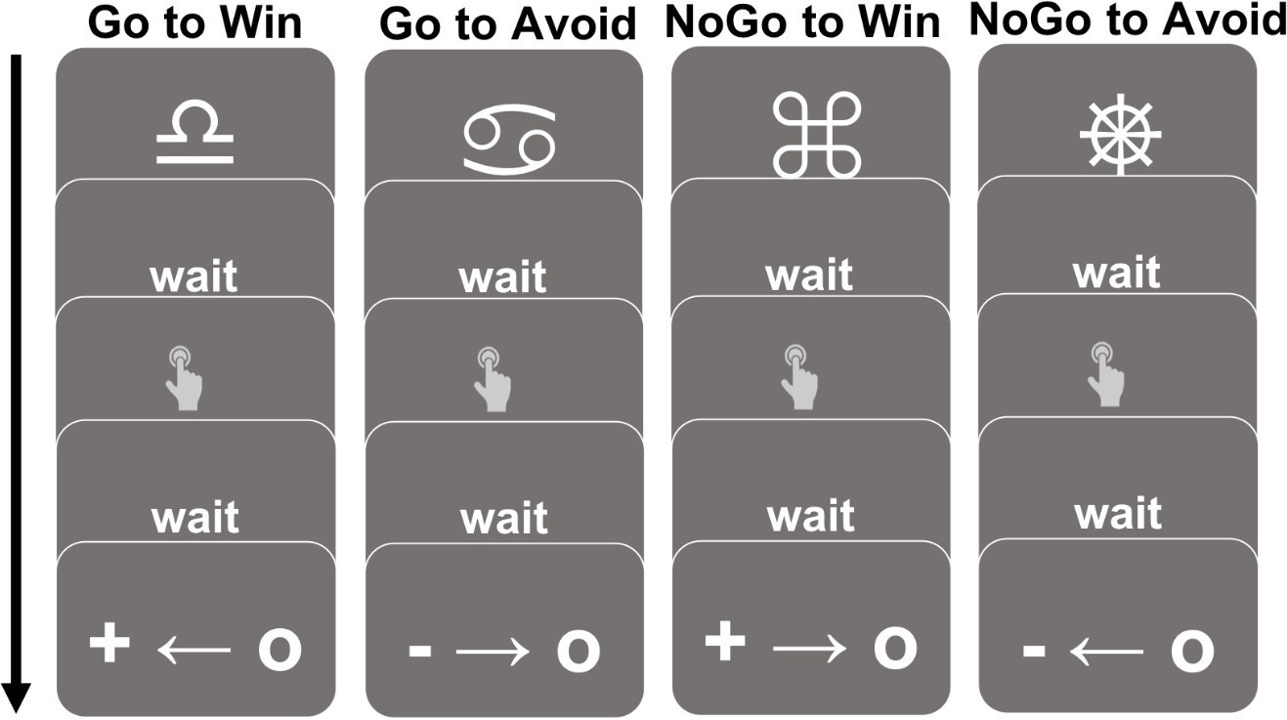

1. The Mood-Machine-Interface Task

The Mood-Machine Interface task is designed to measure the changes in participants’ transitory mood in response to potential unexpected monetary gains and losses. The task aims to shift subject’s transitory mood in real-time by modifying the rates of gains and losses the participant responds to. (Please see MMI Instructions and Images”)

For instance, in each trial, participants are asked to choose between two options--one associated with an unknown probability of a gain or loss and the other a certain gain or loss. Participants must choose between the certain value versus the potential gain or loss. After the choice is made, the outcome is revealed. Subjects also rate their mood after every 2-3 trials. The mood rating consists of two phases: (1) a presentation of the question “How happy are you at this moment?” and (2) a continuous rating scale allowing time for the subject to move a curser that appears at the midpoint along a line, to the left or right. The scale is labeled “unhappy” on the left end and “happy” on the right end.

The exact amounts of monetary gains and losses are modified during the task according to the reported changes in a subject’s mood as the subject plays. Values will be increased to push mood upwards and decreased to push mood downwards. All values during the task will be presented as points, ranging from -40 to +40, and at the end of the task these points are computed to a proportionate monetary value between $5-$35. Task includes 3 blocks of 20-30 trials each, and a total of 30-40 mood ratings.

1. Contingency Task (ConTA)

The ConTA seeks to measure people’s behavior and emotional responses to the same stimulus, under changing environmental contingencies. By studying this dynamic, we will gain insights into the relationship between daily life environments and emotional wellbeing, together with its dynamics with reward processing.

ConTA has two parts: the primary task and the rating task. The “primary task” is expected to take up to 30 min to complete; the “rating task” that follows it will be presented for up to 10 min. We plan to pilot the two tasks in a single session with a total ConTA task time for the worker of 40 min.

Approximately 45 min of additional time is required to complete the Questionnaires (see below) that accompany the ConTA. Thus, the total time for the primary task, rating task, *and* Questionnaires (70+10+45=125) will not exceed 125 minutes.

The “primary task” asks subjects to view 30 short videos extracted from suspenseful movies. On every trial, after viewing the videos, they will be asked to make a choice for the character in the video that optimizes the chance of survival. The same video and choice will appear multiple times, but with different environmental contingencies. Subjects receive neither reward nor punishment from their choices. However, they will be told how many characters are “saved” through their actions every 5-15 trials.

The “rating task” presents subjects with screenshots they already saw during the “primary task”, and ask them to rate properties of the screenshots, including familiarity and the level of suspenseless.

All videos can be accessed via the private YouTube channel: [https://youtube.com/playlist?list=PLtiwojLfExDVM0v169AO-cDKft_MlV69P](https://www.youtube.com/playlist?list=PLtiwojLfExDVM0v169AO-cDKft_MlV69P)

None of the videos contains any form of vivisection, gore, or forms of violence. Details of the task are described below.

In the beginning of a trial, subjects will watch a short video (5-10 seconds) excerpted from a suspenseful movie scene. They are instructed to assume the role of the main characters in the video and choose one of two actions based on what they consider to be best. After the video, they will see another screen with descriptions about the surrounding environment. In the relevant contingency condition, there will be items placed around them that could help them resolve the situation; in the irrelevant contingency condition, there will be items placed around them that are irrelevant to the suspenseful scenario. An example is below:

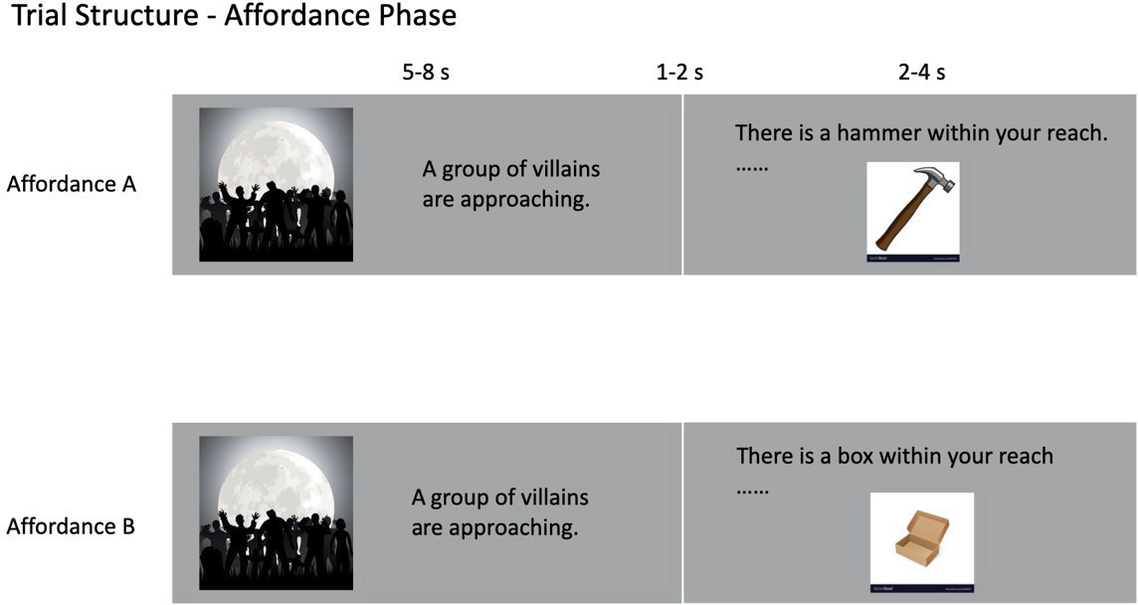

After being presented with the environmental affordance, subjects will be asked to answer subjective questions (as per below) such as “How fearful do you feel?” and “How angry do you feel?” by moving a cursor along a continuum on the screen to match a number that reflect their relative rating.

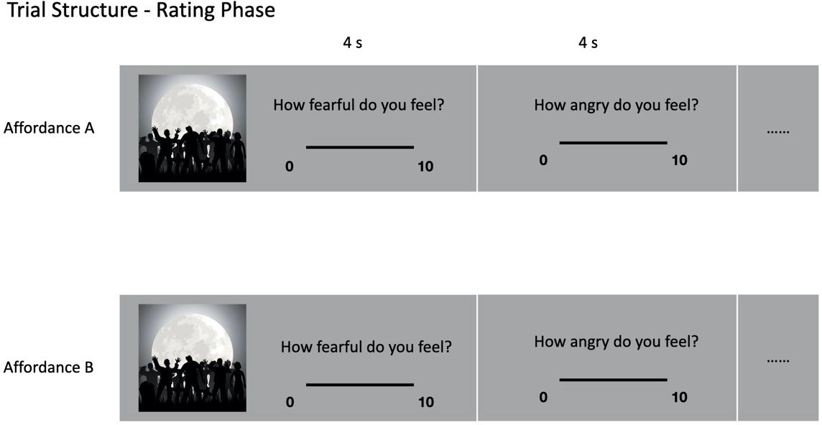

At the end of a trial, subjects will be asked to make a choice between a forceful response (attempt to solve the situation) and an avoidance behavior (escaping the situation). No matter what contingency condition they are in, the forceful response always has a 50% chance of success and the avoidance behavior has a 100% chance of success However, battling through to solve the situation is considered a better action than merely escaping, and will improve the subjects’ performance rating. Subjects receive no punishments from failing a particular trial.

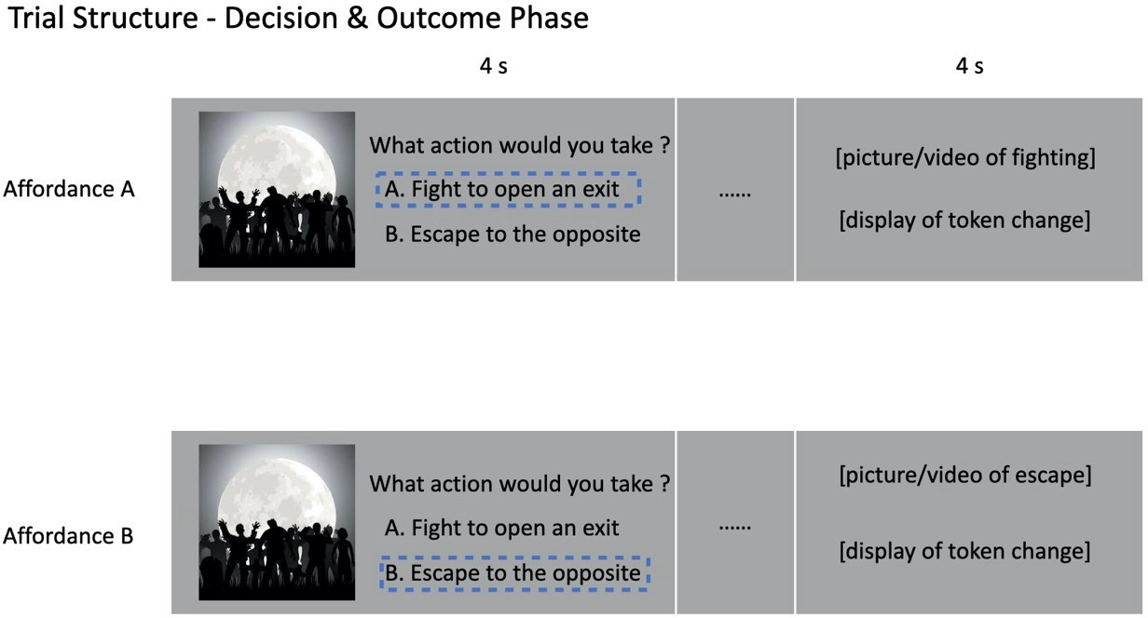

1. Letter Task (LT)

The LT is used to investigate the relationship between effort, reward, and mood. By varying the effort demanded and reward provided by the task while measuring subjective mood change, the LT seeks to understand how individuals respond to different effort-reward relationships in the real world.

Approximately 45 uninterrupted minutes is required to complete the primary task and 15 min of additional time is required to complete the Questionnaires (as per below) that accompany the LT. Thus, the total time for the primary task *and* Questionnaires (45+45=90) will not exceed 90 minutes.

On every trial of the LT, participants see a string of letters of various length. The participants’ task is to sort the letters alphabetically. After a period of time in which they can memorize and sort the letters mentally, they will be asked to indicate the position of a target letter in the sorted string. Participants respond with their keyboard numeric keys. Participants may be rewarded with points after each trial. The reward may depend on if they responded correctly or not, other characteristics of the trial, such as the number of letters, or it may be random. At some point during each trial, participants may be asked to subjectively rate how much effort they put in and/or to rate their mood using a scale. The participants are informed prior to the start of the task that their bonus compensation is based on the total points they accumulate throughout the task.

Participants may be told that they will receive bonus points after the task based on the number of correct responses.

The subjective measures of the task (mood and effort) are recorded using an infinite precision on- screen analog scale.

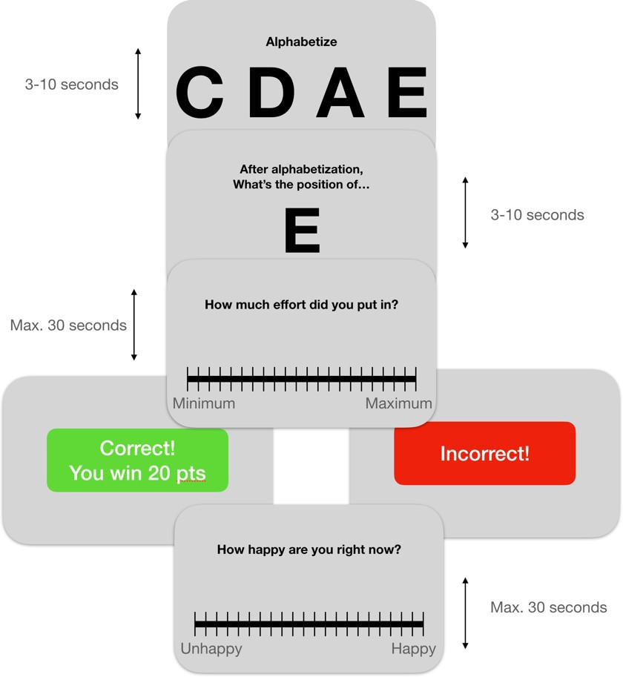

For the LT, subjective effort also will be assessed using self-rating scales and participant responses to prompts during the tasks that ask questions like “How much effort did you put in?”, “How hard did you try”, or “How hard was this trial”. The scale will have “Minimum” on the left side and “Maximum” on the right side. We may include practice trials at the beginning of the tasks to help participants calibrate the most and least difficult trials they will see during the task

## Objective measures for the LT

Objective measures are the choices made by participants in the tasks. For the LT, Objective measures also include the response made by participants in the tasks as well as the time for them to make the response.

## Subjective measures for the LT

Subjective measures of mood, anhedonia, and motivational features will be assessed using self- rating scales and participant responses to prompts during the tasks that ask about “How happy you are at this moment?” “How fearful do you feel at this moment?” “How angry do you feel

at this moment?”

1. The Mood-o-Meter Task

In the Mood-o-Meter task, participants observe their scores and their gains or losses at every trial. In between, they rate their mood when prompted. This image describes the structure of the task:

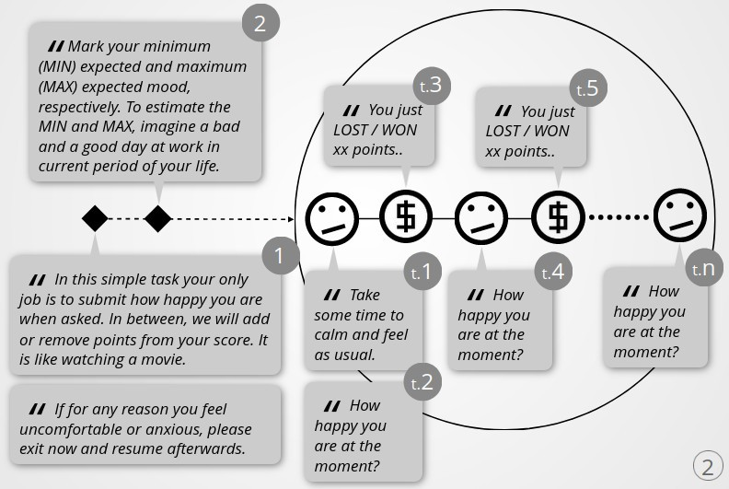

In the diagram, each segment of the task is marked with number.

1. In the first segment, we describe to the participants the rules and their role.
2. In the second segment, we ask participants to mark their maximum and minimum expected mood values. These first two steps are presented at the start and not repeated afterwards.

The mood-o-meter ranges from negative to positive with zero at the mid-point, from bad to good mood values, with a numerical value range of minus one to plus one. During the trial participants record their current mood. The marks are visible to the participant throughout the game, that is, the participants can always see their MIN, MAX, and last marked mood values.

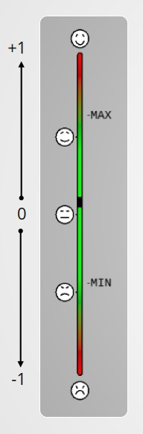

1. The third segment is the main game sequence of trials. The big circle on the right indicates these trials, each step of which is marked with a “t” at start. In the task we use three different “environments,” and thus there will be three repetitions of the circle with different settings at each one. At the beginning of each trial, the score resets to zero; participants are asked to take time to relax. The participants’ starting points are zero and, in each round, the participant has the potential to lose points, meaning, the there is a possibility that participants may receive a negative score.

There are three sub-parts or “environments” to the task. One with a pre-defined “pseudorandom” (fixed) sequence of rewards/punishments—the same for all participants—and two with the outcome based on a function of the last mood input. Functions used for these two environments are “rn=i*mn” and “rn=(-i)*mn”, where “r” is for reward/punishment, “m” for mood value, “n” for the round number and “i” a positive number, which we have set to 50, and is actually the maximum absolute value of reward or punishment.

There is no action for the participants beyond inputting their mood; the task is merely a continuous mood input 🡨🡪 reward cycle. Each cycle consists of 20 to 40 rounds with a maximum of 100 rounds; the duration of the task is approximately 40 minutes. Thus, the total time for the Mood-o-Meter task *and* Questionnaires (45+45=90) will not exceed 90 minutes.

The Trial’s sequence of images is:

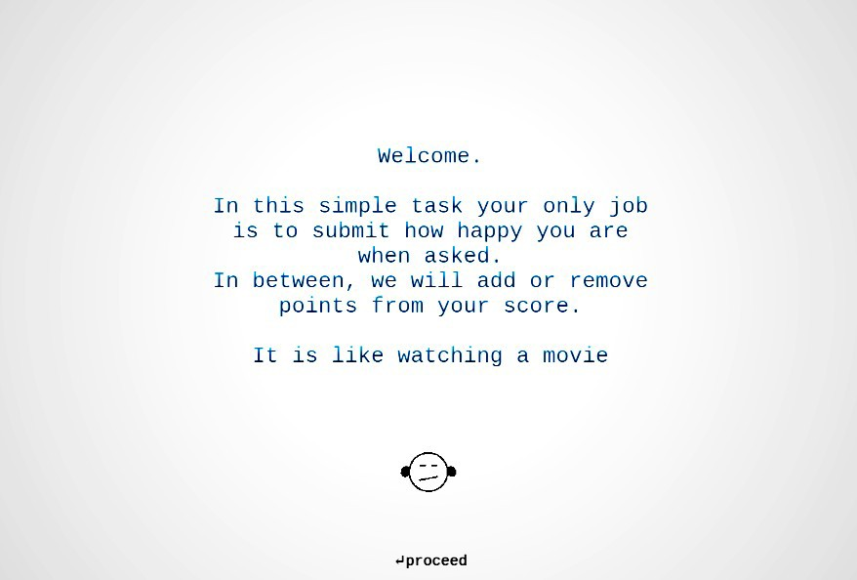

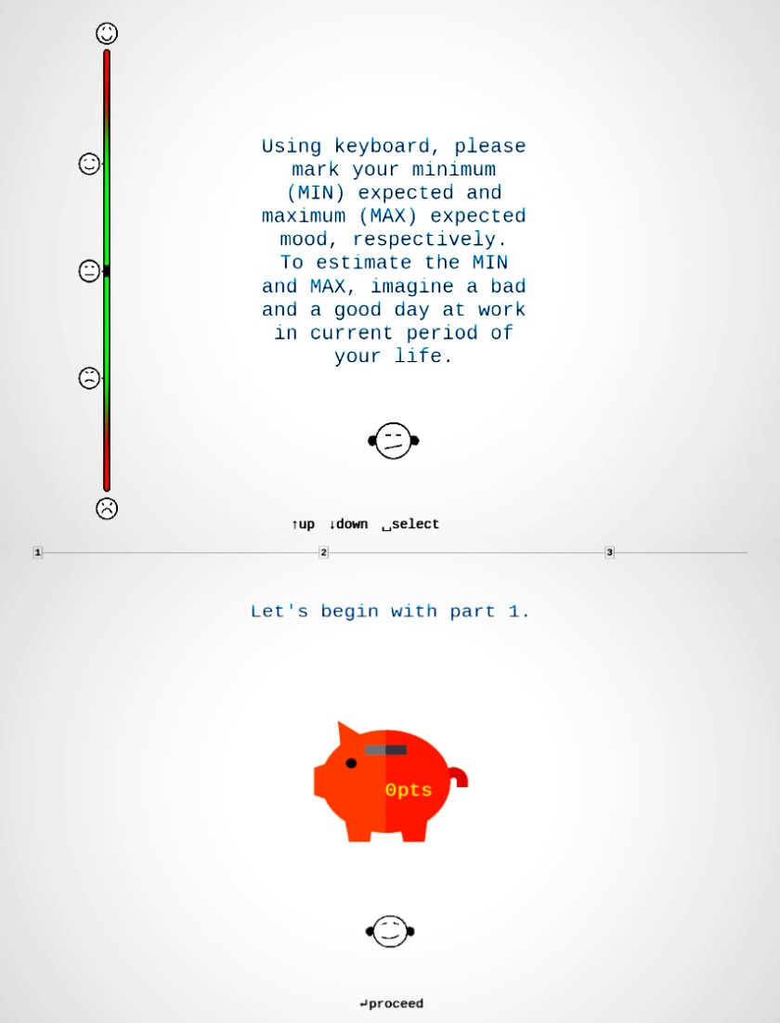

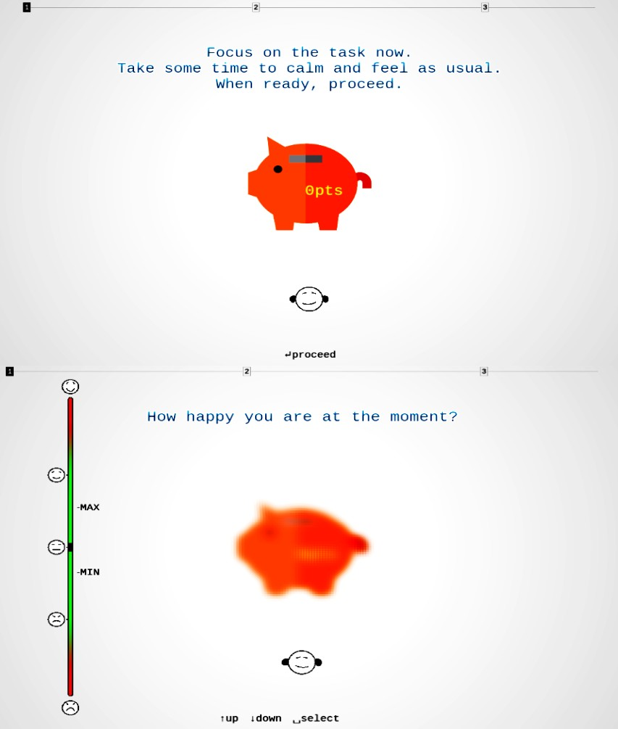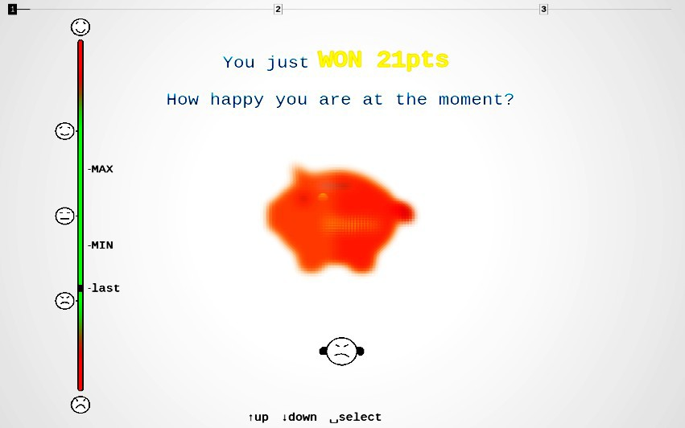

**WON 21 Points**

1. Flanker Task

The flanker task is a common assessment of inhibitory control, or an individual’s ability to ignore goal-irrelevant information and focus on a particular visual input. We have developed a novel variant of the original task called Flanker3, which provides more nuanced challenges to an individual’s visual attention. Participants are shown a target followed by an array of arrows.

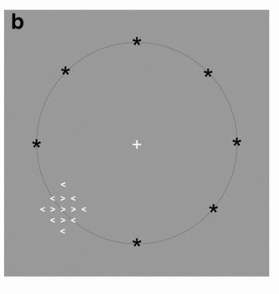

In the figure to the left, we show the possible stimulus locations on the screen. Black asterisks show the eight locations where a stimulus could have appeared on each trial. The black asterisks and circle are shown here for illustration; they are not shown during the task

Distractor arrows within the array may be congruent to the target or may provide mixed evidence for the two possible responses with differing difficulty (mixed easy and mixed hard) as shown below. Mixed evidence trials consistently result in lower accuracy and slower response times (RTs). We created a metric score for the flanker task that is calculated to account for both speed and accuracy. To achieve a perfect score of 1.0, the participant must respond quickly and accurately in all 3 conditions.

In the image to the left, colors are used to highlight the possible contrasting orientations of the arrows, but in the actual task stimuli are presented with white font against a dark gray background.

Participants will be shown instructions as follows:

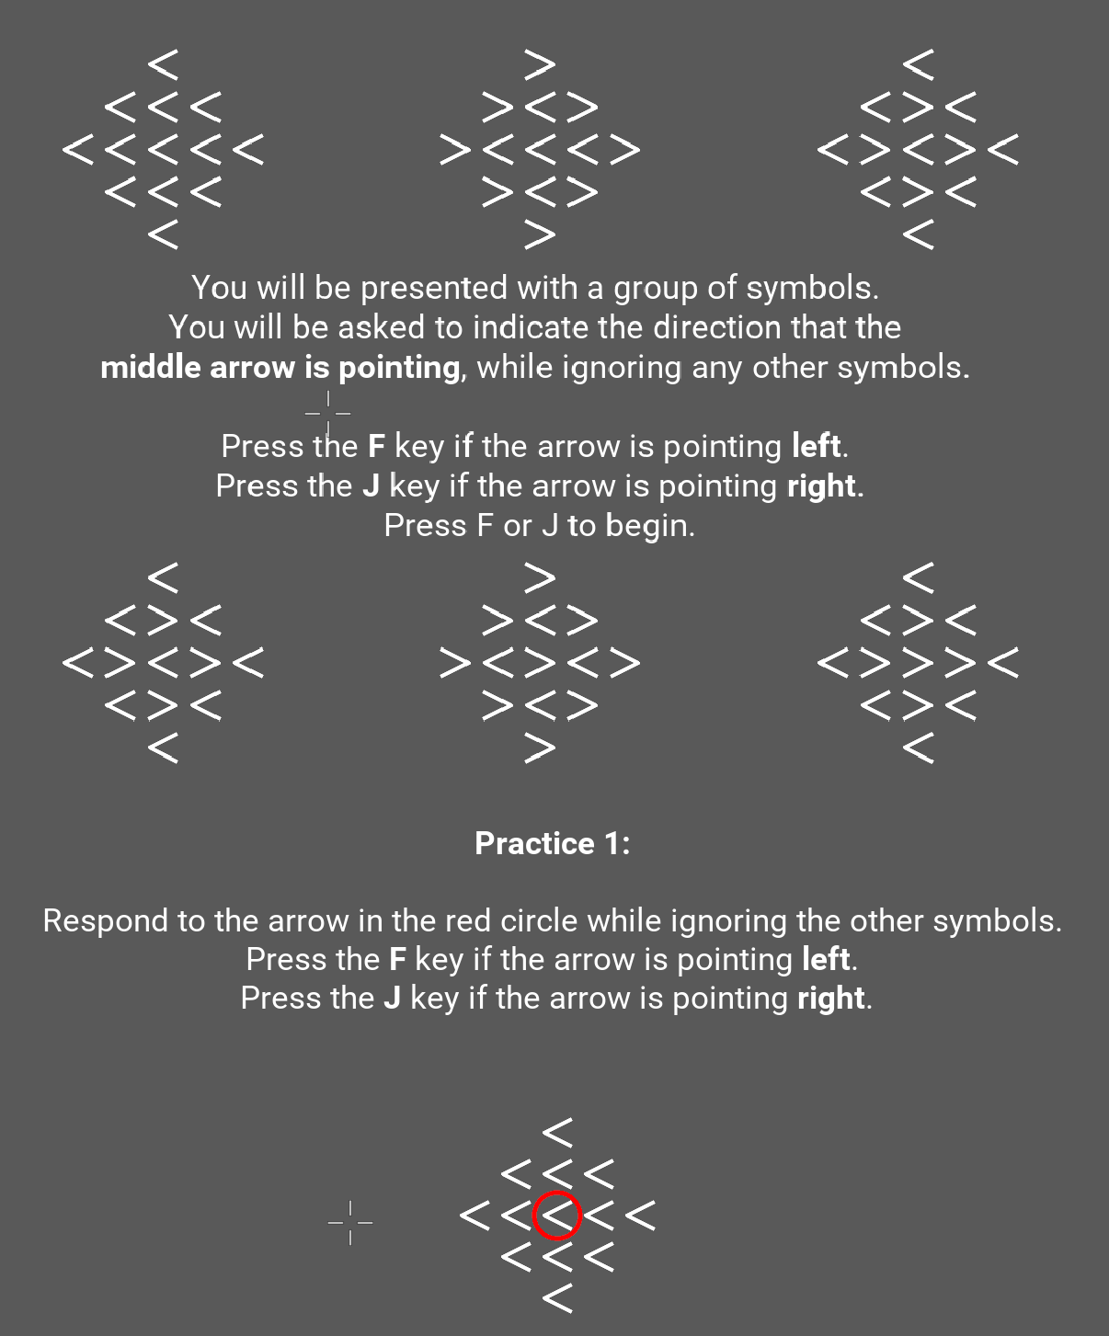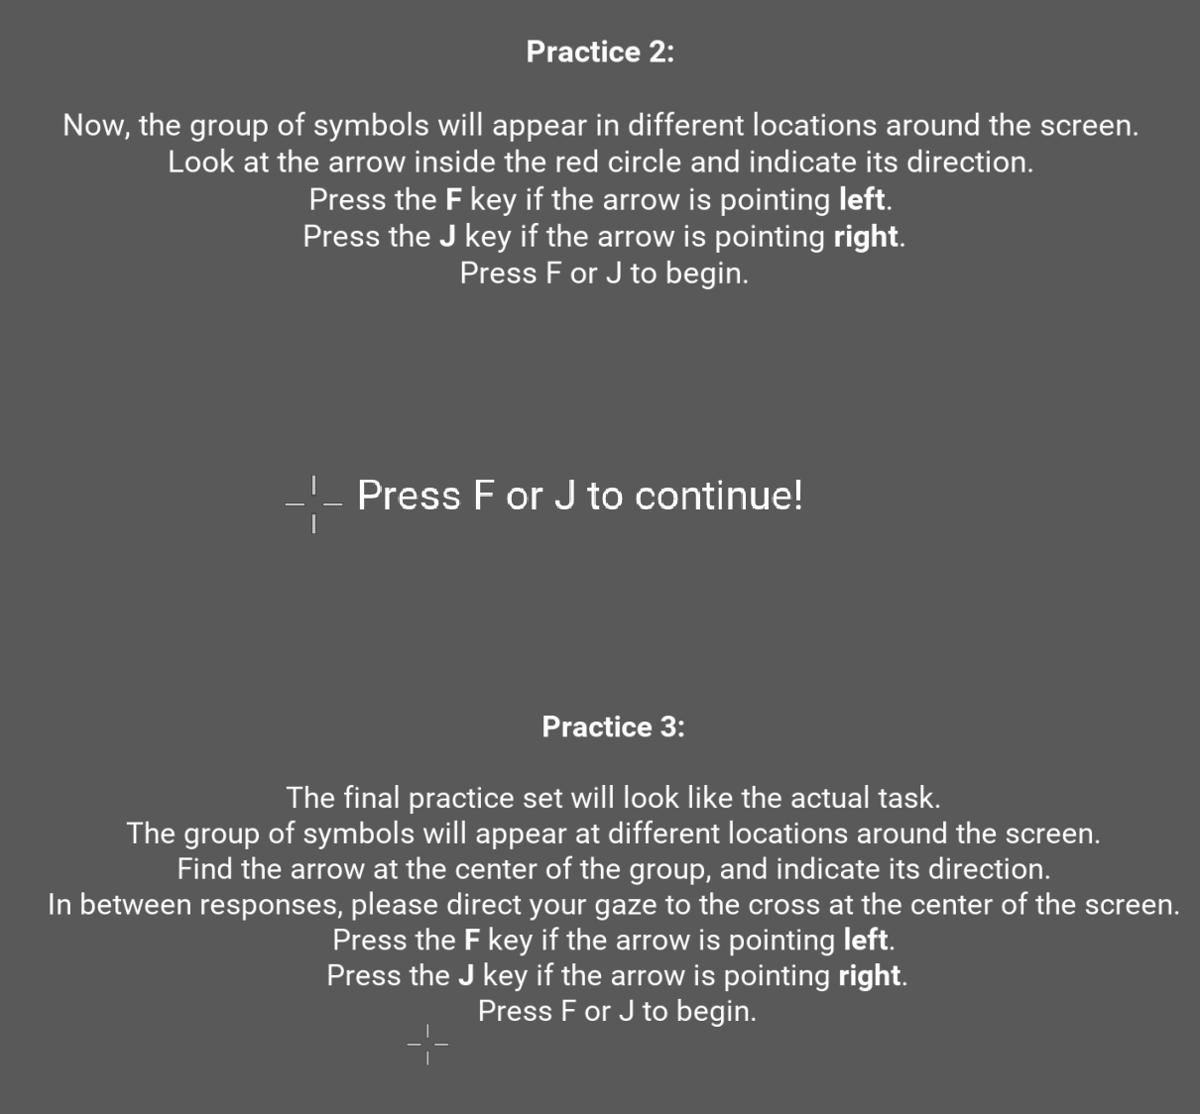

1. Dot Probe task

This task (a random dot motion task) is a widely-used perceptual decision-making task. On each trial, participants are presented with a cloud of dots where some proportion of the dots move randomly. The objective for the participant is to decide which direction (either left or right) has a greater proportion of dots moving together. On some trials, it is clear which direction the most dots are moving together, but, on other trials, it is not as easy. After each trial, the participant is immediately presented with feedback which reveals if they answered correctly. Our performance score (higher scores indicate better performance) accounts for both the accuracy of the participant and how much time they require to make a response.

(Participants see this image to start. Dots then move in one direction or another, as examples diagrammed below indicate)

Participants will be shown instructions as follows:

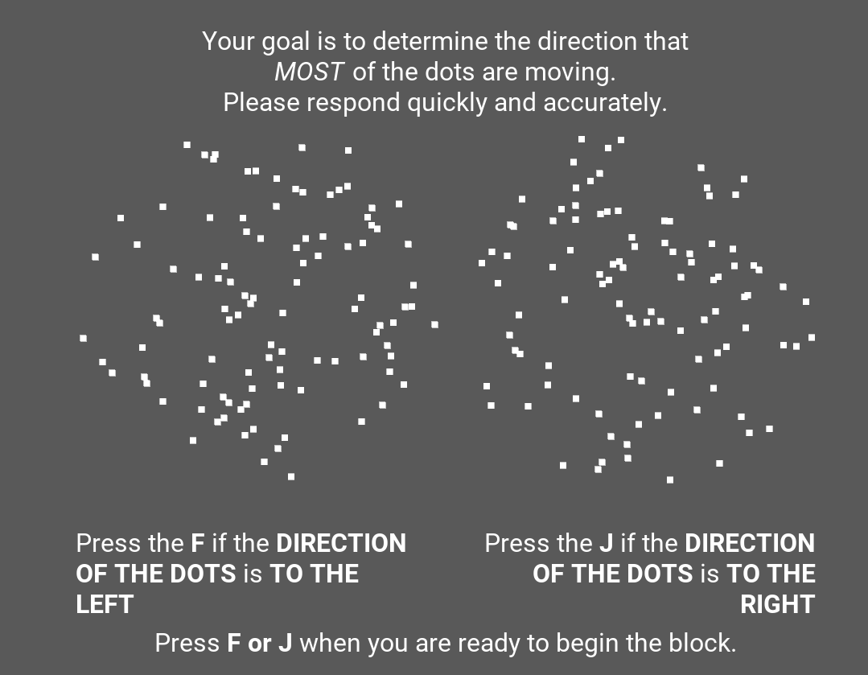

1. Continuous Associative Binding (CAB) Task

In the CAB task, participants are presented with pairs of objects, and on each trial are asked to indicate whether the pair is new or old. Each object is presented 3 times in an “intact” pair, and once in a “recombined pair.” In order to discriminate between repeated intact pairs and recombined pairs, since the objects have been seen before in both cases, participants must associate items together

within pairs. We can distill performance down to a single overall score that takes into account accuracy and response time and has a range between 0 (worst possible performance) and 1 (best possible performance).

(These are examples of images that will be shown. The drawings will be selected from a universe of 1,995 neutral images of everyday objects; objects are selected *without* any intent to evoke emotion and none display people, weapons, or words.)

Participants will be shown instructions as follows:

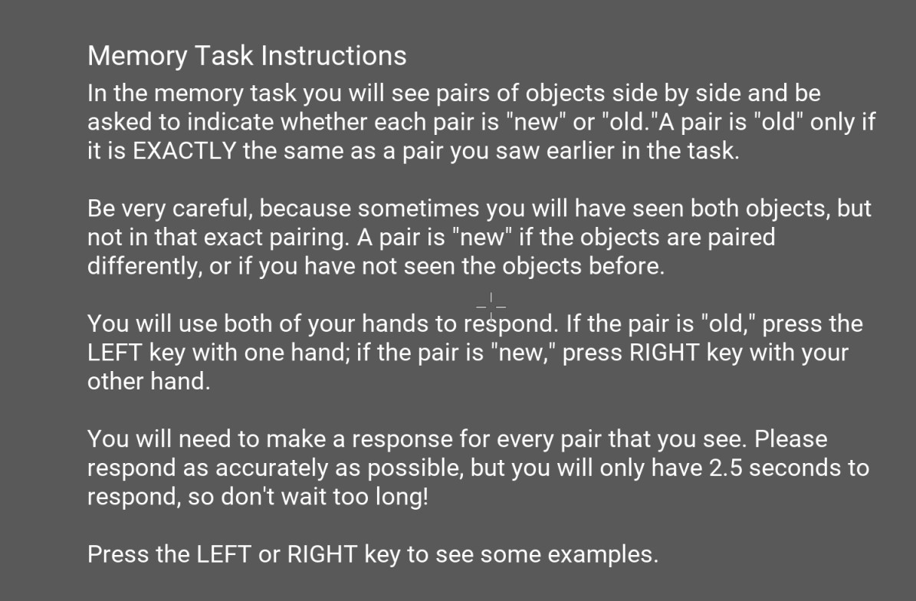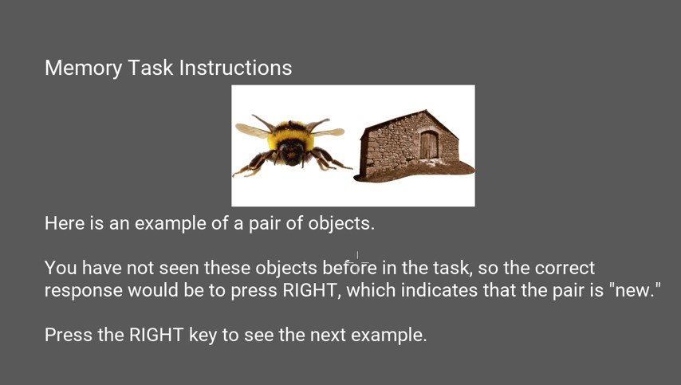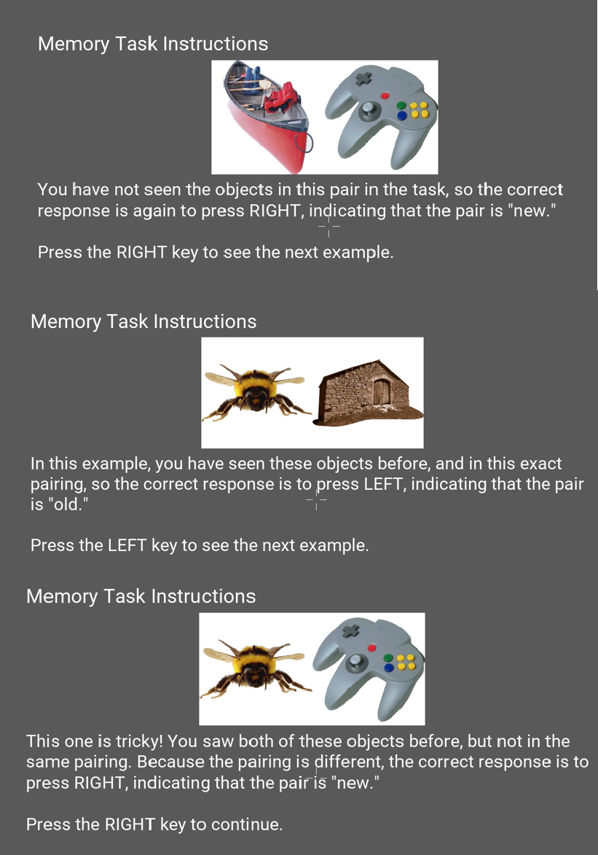

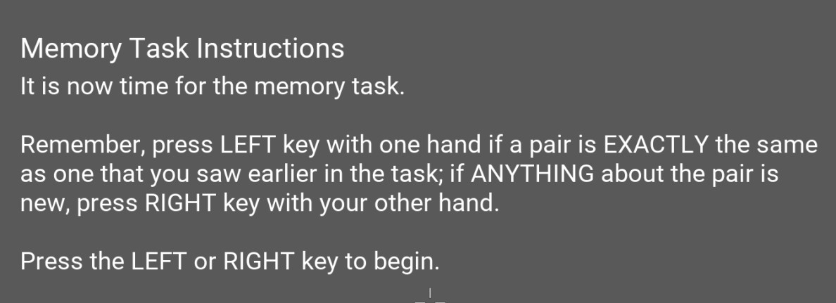

1. Balloon Analogue Risk Task (BART)

A critical function of assessing an individual’s cognitive state is ascertaining their risk-taking behavior. In the Balloon Analogue Risk Task (BART), participants are presented with a series of balloons with the goal of earning as much money as possible. A participant must decide whether or not to pump each balloon. At every decision, the participant is presented with a reward value underneath the balloon. At every decision time, the participant must decide whether to pump the balloon (thereby increasing its value), or they may stop pumping and collect the balloon’s current value. If the participant decides to pump, the reward is then added to the current value of the balloon. However, there is a chance that the balloon may pop, causing the money stored in the balloon to be no longer collectable. If the participant instead decides to collect the balloon, the balloon’s stored value is added to their “bank”. In our version of the BART, we have created 3 different types of balloons which we refer to as “bags” in the context of the experiment. Each bag contains balloons that have a predetermined popping point selected from the same distribution and have the same color. Participants are not informed what the popping probabilities for each balloon type is: Rather, they must learn through trial and error when they should collect balloons in order to maximize their rewards. In order to earn more money, participants must decide when they should explore the pop probability spaces and when they should exploit the knowledge they have gained.

Performance in BART is determined by comparing a participant’s performance to the possible optimal performance given their experimental context. This metric has a range of 0.0 to 1.0, with

0.5 being optimal performance. Participants with a score below 0.5 performed conservatively in that they tended to collect balloon prior to the optimal collection point. Participants with a score above

0.5 tend to take greater risks in pumping the balloons and choose to pump past the optimal collection point.

(All images will appear like this one. Dollar amounts and numbers beneath the objects (e.g. “1 to collect”; “4 to pump”) will change during the task.)

Participants will be shown instructions as follows:

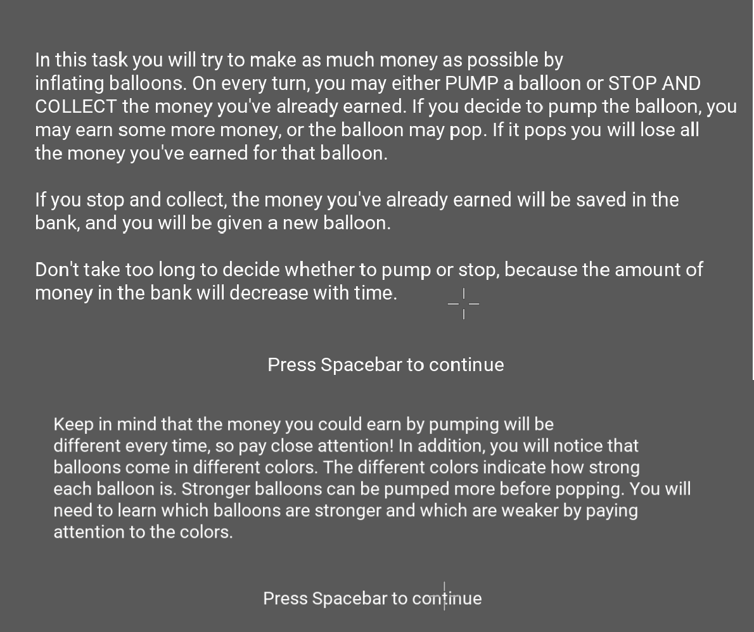

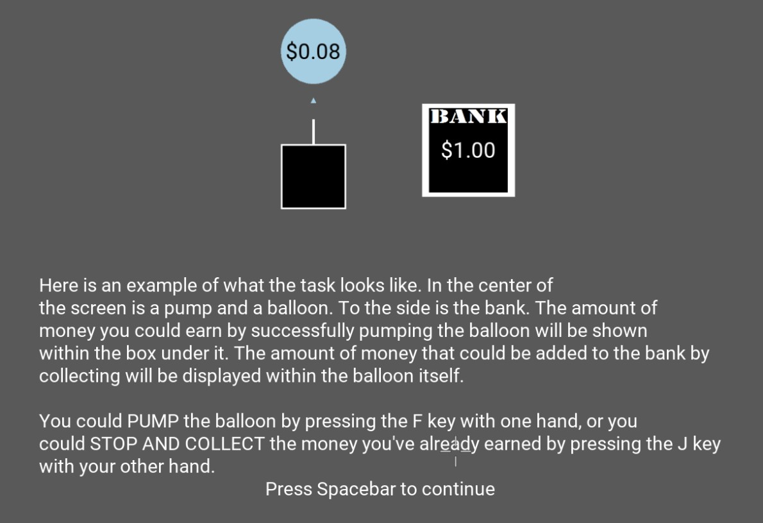

11) Doors

## Approach and avoid motivations are the drivers of everyday behavior but are often in conflict. The suboptimal resolution of this conflict is strongly associated with maladaptive behavioral outcomes in psychopathology. Specifically, anxiety is associated with excessive avoidance and depression is associated with diminished approach. Since both outcomes may manifest similarly in behavior but arise from distinct processes, it is important to find experimental methods to separate these motivations. We developed the Doors task which separately quantifies these motivations, and their interaction. In the task, the subject is instructed that they will encounter a series of animated doors, each hiding behind it either reward (win coins) or punishment (lose coins), with a 50/50 chance for either. Their goal is to collect coins which would be converted into money at the end of the task. To one side of the door, the magnitude of potential reward is presented (1-7); similarly, the magnitude of potential punishment (1-7) is presented on the other side. Using a joystick, the subject decides how close to get to the door; the closer to the door that the position themselves, the more likely it is to open and reveal the outcome. This is a sample door:

## If the door opens, the outcome is either winning or losing, and is presented visually as such:

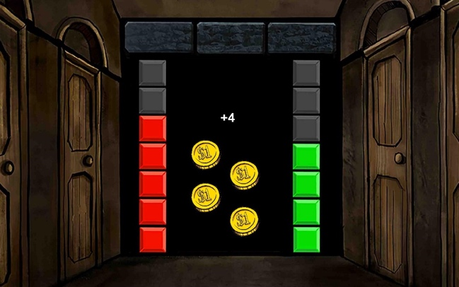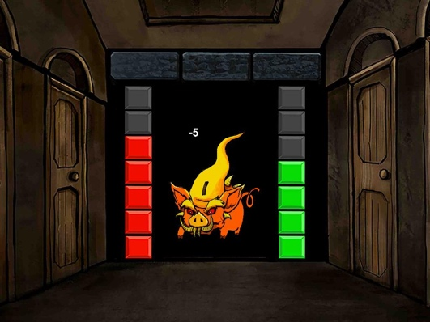

## The task will be administered in up to 3 blocks and take up to 30 minutes. All values during the task will be presented as coins, and at the end of the task these points are computed to a proportionate monetary value between $1-$15. Performance is calculated as a linear regression in which the trial-level magnitudes of potential reward and punishment are entered as predictors of the chosen distance.

## Questionnaires

These questionnaires will be completed after the tasks have been completed. Three questions will be used to obtain demographic information about the subjects: the worker’s age, the worker’s sex, and this one question from the MacArthur Network on SES & Health (<https://macses.ucsf.edu/research/socialenviron/sociodemographic.php>):

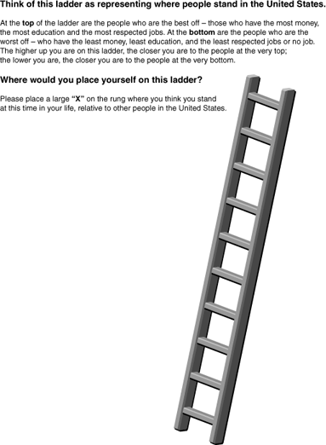

*No names or other personal identifiers will be requested*.

In addition, we will utilize standardized questionnaires about mood, pleasure, motivation, and anxiety. *None* of the questionnaires will have “actionable” items, that is, items that would require urgent medical or psychiatric intervention or imminent risk for participant safety, such as a yes-or-no prompt like “I feel like killing myself.”

The questionnaires will be selected from this list:

1. Snaith–Hamilton Pleasure Scale (SHAPS) (14 items). From (Snaith et al., 1995).
2. Center for Epidemiologic Studies Depression Scale (CES-D) scale (20 items). From (Radloff, 1977).
3. Perth Alexithymia Questionnaire (PAQ) (24 items).
4. Machiavellianism Test (MACH-IV) (20 items).
5. Short Boredom Proneness Scale (8 items, rated on a 7-point Likert Scale). From (Struk, 2015).
6. Mind-Wandering Questionnaire (5 items, rated on a 6-point frequency scale). From (Mrazek, 2013).
7. Multidimensional State Boredom Scale, Short Form (8 items, rated on a 7-point Likert Scale). From (Oxtoby, 2016).
8. Multidimensional experience sampling (13 questions about the contents of ongoing thought, rated on a 0-1 slider). From (Turnbull, 2019)
9. Patient Health Questionnaire depression scale, PHQ-8 (8 items rated on a 4-point frequency scale). From (Kroenke, 2009).
10. Generalized Anxiety Disorder scales, GAD-7 (7 items rated on a 4-point frequency scale). From (Spitzer, 2006).
11. Barkley Adult ADHD Rating Scale -IV self-report (BAARS-IV) modified to ask about the previous 2 weeks (27 items rated on a 4-point frequency scale). From (Barkley, 2011).
12. Selected items from the Preliminary HiTOP Internalizing Spectrum Scales modified to ask about the previous 2 weeks (83 items rated on a 4-point scale). From (Watson, 2022).
13. CTADS EMA: Items about social interaction, depression and related symptoms, and sleep (37 questions multiple choice or on a visual analog scale).
14. Mood, anxiety, and attention diagnosis and treatment information (10 multiple choice questions about
15. Items about the specific cognitive tasks the participants just completed.
16. State Trait Anxiety Inventory, STAI (40 items rated on a 4-point frequency scale). From (Spielberger, 1983).
17. Behavioral Inhibition System/Behavioral Activation System scales, BIS/BAS (22 items on a 4-point Likert scale). From (Carver, 1994).
18. Behavioral Anger Response Questionnaire, BARQ (37 items on a 3-point frequency scale). From (Miers, 2007).
19. Liebowitz Social Anxiety Scale (24 items each 4-point severity scales for fear/anxiety and avoidance). From (Liebowitz et al., 1987).
20. Multidimensional Experiential Avoidance Questionnaire, MEAQ (62 items on a 6-point agreement scale). From (Gamez et al., 2011).
21. Intolerance of Uncertainty Scale, IUS (27 items on a 5-point scale from “Not at all characteristic of me” to “Entirely characteristic of me”) or the 12-item version of this measure, IUS-12. From (Carleton, 2007).
22. WHO Disability Assessment Scale, 12 item , WHODAS-12 (12 items on a 5-item scale severity scale and 3 items assessing days affected). From (WHO, 2014)
23. Affective Reactivity Index (ARI) 7-item self-report on irritability from (Stringaris A, Goodman R, Ferdinando S, Razdan V, Muhrer E, Leibenluft E, Brotman MA. The Affective Reactivity Index: a concise irritability scale for clinical and research settings. J Child Psychol Psychiatry. 2012 Nov;53(11):1109-17.)
24. Beck Hopelessness Scale 20 true-false items about hopelessness. From (Beck et al., 1974)

These questionnaires may be administered in any order or combination and may have trials of the other tasks in this protocol interleaved in these blocks. The questionnaires may be administered before, during, or after tasks. Different participants will receive different subsets of questionnaires, but the total time on questionnaires for any individual participant will not exceed 45 minutes.

# Compensation:

Payments will be provided to subjects via the PMP that provided the links to participate in the study. Study personnel will identify unique codes corresponding to completed responses on the DCPs, determine which participants received those codes on the PMP, and approve participant payment through the PMP. The PMP will obtain personal identifiers of subjects participating in the study but will not provide us with this information. We will use the PMP to distribute payment and bonuses (around $3.00) (range $1 to $6, based on winnings) to the Subjects but unique platform identifiers will not be stored with the survey responses or data. In addition, going forward, all subjects will be paid at least $8/hour per session and no more than $17.50/hour per session for their participation in the study in addition to any bonuses earned. The investigators will have no access to any personal identifiers associated with compensating subjects.

# Risks and Benefits of Participation:

**Risks**: The study involves no more than minimal risk to participants (i.e., the level of risk encountered in daily life).

**Benefits**: There is no direct benefit from participation in this study.

# Data Analysis and Plan

There are three steps:

Data import, cleaning, and description: Data will be imported into R or Python and analyzed, and scripts will be run to test their integrity (outliers, plausibility of values, etc.) and basic descriptives of clinical scores as well as responses to tasks (% correct, reaction times etc.).

Model fitting: the second step involves fitting of basic models to our data. These include simple Q-learning models and squashing of the probabilities through SoftMax functions in keeping with our previous lab’s work. In particular, we will be modeling the prediction error and its updating of future expectations. For the Flanker3, Dot-probe, CAB, and BART tasks, we will fit Bayesian models to estimate behavioral parameters from participant performance.

𝑃𝐸t = 𝑟t – 𝑄t-1

Where rt, is the reward received at time t (e.g., whether a subject received $1 in a gamble); Qt-1 is the anticipation of reward; the t-1 denotes that this expectation is shaped by the outcome of the previous trial.

𝑄t = 𝑄t-1 + 𝜀𝑃𝐸t

Where Qt is the expectation about reward that is learned based on the previous trials (occurring at time point t-1), and where ε is the learning rate that scales the PE (i.e. equation 1 above).

These models are only presented here as indicative. We will extend these and adjust to aspects of the tasks such as the fictive feedback as the study progresses.

Regular regression: Parameters from the above models will be extracted in Python or Matlab and will be regressed on clinical variables using regular linear regression models.

For the Contingency Task, Data will be imported into R, analyzed, and scripts will be run to test their integrity (outliers, plausibility of values, etc.) and basic descriptives of clinical scores and

responses to tasks (% correct, reaction times etc.).

# Data Storage and Confidentiality:

The study data will not be linked to any personal identifiers and will not be able to be linked to subjects by the NIMH research team.

The DCPs used in this study will collect IP addresses and device identifiers from participants as part of their metadata. On Pavlovia, this information is not provided to researchers and is not associated with participant responses. See Pavlovia’s notice about [GDPR](https://pavlovia.org/docs/legal/gdpr). Logs of this information are not retained beyond 3 months. Pavlovia does not access survey responses or task data. Data collected on Pavlovia will remain on Pavlovia’s servers until transferred to secure servers at the NIH by study personnel. Tasks and questionnaires run on Pavlovia will consist of JavaScript code created via PsychoPy. PsychoPy does not receive any information from tasks or questionnaires.

On SurveyMonkey, questionnaires will be collected via the “Anonymous Responses” option, which prevents SurveyMonkey from including IP addresses or other identifiers as part of the responses (which is its default setting). If SurveyMonkey accesses and analyzes survey data, they only do so once they aggregate and anonymize or pseudonymize the data. See SurveyMonkey’s [Privacy Basics](https://www.surveymonkey.com/mp/legal/privacy-basics/). Data collected on SurveyMonkey will remain on SurveyMonkey’s servers until transferred to secure servers at the NIH by study personnel.

PII collected by the participant management portion of YouGov is not stored with the data collection portion of YouGov. Members of the team managing data collection on YouGov do not have access to that PII, and access to the information is very restricted. PII is not linked with survey responses for any analyses. See YouGov’s [Privacy Information](https://account.yougov.com/us-en/account/privacy-policy) and [Security and Audit Practices](https://corporate.yougov.com/esg/governance/our-data-commitment/our-approach-security/).

Data will be transferred from DCPs to NIH servers once every two weeks. After data has been transferred from DCPs, copies on the DCPs servers will be deleted. In the case of YouGov, the primary versions of the survey data will be deleted once it is transferred to NIH servers. However, YouGov retains backups of data for a limited time, approximately 90 days depending on the specific servers and time of data collection.

All the research data will be stored on secure servers at NIH. All the data is anonymized and will not be able to be linked to any identifiers by the NIMH research team, i.e., there is no code key at NIH. No NIH staff will have access to the code key or any identifiers.

Only Dr. Nielson and members of the Emotion and Development Branch, members of the Machine Learning Team, or individuals in the labs of external collaborator will have access to the data as collected.

We will make a version of the data collected as part of this protocol publicly available via data sharing platforms such as GitHub. We will remove potentially identifying information including all dates. While the NIH is not covered by HIPAA, we will use Section 164.514(b)(2) of the HIPAA Privacy Rule as a guide for removing potentially identifying information. Any information about the relative timing of multiple sessions will be rounded to the nearest hour. Any information about relative timing of previous diagnoses will be rounded to the nearest year.

# References

Angold, A., Costello, E. J., Messer, S. C., & Pickles, A. (1995). Development of a short questionnaire for use in epidemiological studies of depression in children and adolescents. *International Journal of Methods in Psychiatric Research, 5*(4), 237-249.

Barkley, Russell A. (2011). *Barkley Adult ADHD Rating Scale-IV (BAARS-IV)*. Guilford Press.

Beck, A.T., Weissman, A., Lester, D. and Trexler, L., (1974). The measurement of pessimism: the hopelessness scale. *Journal of consulting and clinical psychology*, *42*(6), p.861.

Brown, H. R., Zeidman, P., Smittenaar, P., Adams, R. A., McNab, F., Rutledge, R. B., & Dolan, R.

J. (2014). Crowdsourcing for Cognitive Science – The Utility of Smartphones. *PLoS ONE, 9*(7), e100662. doi:10.1371/journal.pone.0100662

Carleton, R. N., Norton, M. A. P. J., & Asmundson, G. J. G. (2007). Fearing the unknown: A short version of the Intolerance of Uncertainty Scale. *Journal of Anxiety Disorders*, *21*(1), 105–117. <https://doi.org/10.1016/j.janxdis.2006.03.014>

Carver, C. S., & White, T. L. (1994). Behavioral inhibition, behavioral activation, and affective responses to impending reward and punishment: The BIS/BAS Scales. *Journal of Personality and Social Psychology, 67*(2), 319-333. doi:10.1037/0022- 3514.67.2.319

Gámez, W., Chmielewski, M., Kotov, R., Ruggero, C., & Watson, D. (2011). Development of a measure of experiential avoidance: The Multidimensional Experiential Avoidance Questionnaire. *Psychological Assessment*, *23*(3), 692–713. <https://doi.org/10.1037/a0023242>

Gibson, James J. *The ecological approach to visual perception: classic edition*. Psychology Press, 2014.

Kroenke, K., Strine, T. W., Spitzer, R. L., Williams, J. B. W., Berry, J. T., & Mokdad, A. H. (2009). The PHQ-8 as a measure of current depression in the general population. Journal of Affective Disorders, 114(1), 163–173. <https://doi.org/10.1016/j.jad.2008.06.026>

Liebowitz, M. R. (1987). Social phobia. *Modern Problems of Pharmacopsychiatry*, *22*, 141–173. <https://doi.org/10.1159/000414022>

Meads D.M., Bentall, RP. Rasch analysis and item reduction of the hypomanic personality scale. *Personality and Individual Differences*, 44 (8), 1772-1783.

Miers, A. C., Rieffe, C., Meerum Terwogt, M., Cowan, R., & Linden, W. (2007). The relation between anger coping strategies, anger mood and somatic complaints in children and adolescents. *Journal of Abnormal Child Psychology*, *35*(4), 653–664. <https://doi.org/10.1007/s10802-007-9120-9>

Parker G, Fletcher K, McCraw S, Hong M. The hypomanic personality scale: a measure of personality and/or bipolar symptoms? Psychiatry Res. 2014 Dec 15;220(1-2):654-8. doi: 10.1016/j.psychres.2014.07.040.

Pornpattananangkul N, Leibenluft E, Pine DS, Stringaris A. Association Between Childhood Anhedonia and Alterations in Large-Scale Resting-State Networks and Task-Evoked Activation. JAMA Psychiatry. 2019 Mar 13. doi: 10.1001/jamapsychiatry.2019.0020.

Qi, S., Hassabis, D., Sun, J., Guo, F., Daw, N., & Mobbs, D. (2018). How cognitive and reactive fear circuits optimize escape decisions in humans. *Proceedings of the National Academy of Sciences*, *115*(12), 3186-3191.

Radloff, L. S.(1977). The CES-D Scale: A Self-Report Depression Scale for Research in the General Population. *1*(3), 385-401. doi:10.1177/014662167700100306

Sheppes, G., Scheibe, S., Suri, G., Radu, P., Blechert, J., & Gross, J. J. (2014). Emotion regulation choice: a conceptual framework and supporting evidence. *Journal of Experimental Psychology: General*, *143*(1), 163.

Snaith, R. P., Hamilton, M., Morley, S., Humayan, A., Hargreaves, D., & Trigwell, P. (1995). A Scale for the Assessment of Hedonic Tone the Snaith–Hamilton Pleasure Scale. *British Journal of Psychiatry, 167*(1), 99-103. doi:10.1192/bjp.167.1.99

Spielberger, C. D., Gorsuch, R. L., Lushene, R., Vagg, P. R., & Jacobs, G. A. (1983). *Manual for tbc State-Trait Anxiety Inventory (Form Y Self-Evaluation Questionnaire).* Consulting Psychologists Press.

Spitzer, R. L., Kroenke, K., Williams, J. B. W., & Löwe, B. (2006). A Brief Measure for Assessing Generalized Anxiety Disorder: The GAD-7. Archives of Internal Medicine, 166(10), 1092–1097. https://doi.org/10.1001/archinte.166.10.1092

Stringaris A, Vidal-Ribas Belil P, Artiges E, Lemaitre H, Gollier-Briant F, Wolke S, Vulser H, Miranda R, Penttilä J, Struve M, Fadai T, Kappel V, Grimmer Y, Goodman R, Poustka L, Conrod P, Cattrell A, Banaschewski T, Bokde AL, Bromberg U, Büchel C, Flor H, Frouin V, Gallinat J, Garavan H, Gowland P, Heinz A, Ittermann B, Nees F, Papadopoulos D, Paus T, Smolka MN, Walter H, Whelan R, Martinot JL, Schumann G, Paillère-Martinot ML; IMAGEN Consortium. The Brain's Response to Reward Anticipation and Depression in Adolescence: Dimensionality, Specificity, and Longitudinal Predictions in a Community-Based Sample. Am J Psychiatry. 2015 Dec;172(12):1215-23. doi: 10.1176/appi.ajp.2015.14101298.

Watson, D., Forbes, M. K., Levin-Aspenson, H. F., Ruggero, C. J., Kotelnikova, Y., Khoo, S., Bagby, R. M., Sunderland, M., Patalay, P., & Kotov, R. (2022). The Development of Preliminary HiTOP Internalizing Spectrum Scales. Assessment, 29(1), 17–33. https://doi.org/10.1177/10731911211003976

WHO. (2014). *WHO Disability Assessment Schedule 2.0 WHODAS 2.0, Psychometric Qualities.* WHO.